# **Maze** Final Year Project | Project Proposal | Unity Game

Evan Coyne – G00336467  
 Carl Greene – G00321391  
 Louise Corbally – G00313361

Table of Contents

Synopsis **1.0**

Environment **2.0**

Market Research **3.0**

Inspiration **4.0**

Project Plan **5.0**

Swot Analysis **6.0**

Website **7.0**

Website Flowchart **8.0**

Game Flowchart **9.0**

Logo Design **10.0**

Database **11.0**

Software **12.0**

Controls **13.0**

1. **– Synopsis**

This game is set in a series of mazes each with their own unique environments, enemies, challenges and goals. Think of each level as a new story. The player is dropped into this maze and all they know is there’s an immediate danger lurking. They’ve a fixed amount of time to escape the maze and live another day. If the timer reaches 0:00 and the player hasn’t found their way out of the maze a game over event will occur prompting the player to retry. The player will be rewarded with a ranking upon maze completion. For example, Bronze for completing in 90 seconds, Silver for completing 75 seconds and Gold for completing in 60 seconds.

1. **– Environment**

We will create the bulk of the playing environment(s) in Unity itself. The level playing field and scenery will all be made within Unity, however, any props, items or objects the character will engage with will be made in Blender as it is a superior 3D modelling workspace for creating high detail models. We plan on having multiple levels and each level having a distinct setting e.g. a derelict mansion or an abandoned carnival. We’re fortunate in that we have a lot of creative flexibility because our game isn’t in one specific space of time.

1. **- Market Research**

Having only just started game development it is essential that we are aware of how games work, what the player is looking for and other aspects.

The best way to learn something is to practice, most great ideas are like Lego blocks, building off another idea. We needed to figure out our competitors and what other similar types of games are out there, we knew then that we could build on that research to make something that incorporates everything that the users love.

The first game we considered when researching was Pac-Man, which was created over 36 years ago. When Pac-Man was created, there was no other game of its kind, therefore it quickly became popular. We wanted to research the sense of urgency that users get when playing games.

While Pac-Man doesn’t essentially have a timer, it does have ghosts that chase you and get faster as time goes by. Thus, creating an adrenaline rush for the user as they try to beat the ghosts.

In terms of levels, this game has multiple mazes that you can play however   
you need to collect coins to unlock those levels, you can collect the coins  
by returning to the game daily for a reward or by in-app purchases.





Another similar game would be Corn Maze, the goal of corn maze is to maneuver the tractor to the end of the maze whilst avoiding the ghosts and skeletons. In terms of levels, the levels are random and each one is different. If you lose a level it will reset the progress back to level 1. The ghosts fly back and forth like the ones in Pac-Man, however these ghosts can fly through the maze walls. The skeletons wander around the maze but cannot walk through walls.

The only defense the player has is a laser that shoots from the tractor, the game starts off with three lasers, however you can get more shots by picking up lightning bolts that are scattered around the maze. The laser can be used to zap the ghosts and skeletons. Tapping a ghost of skeleton will cause the tractor to emit a laser and destroy the villain.

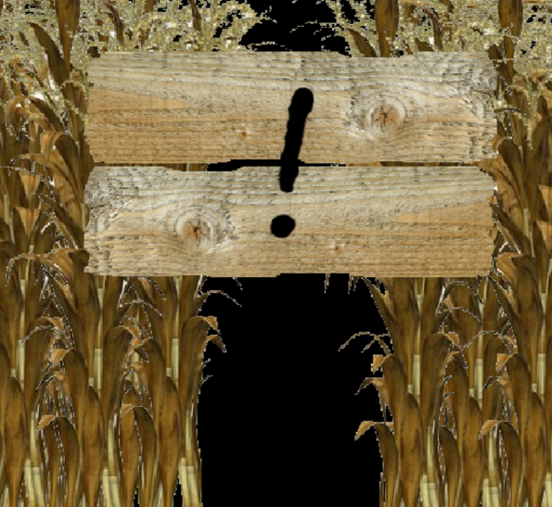

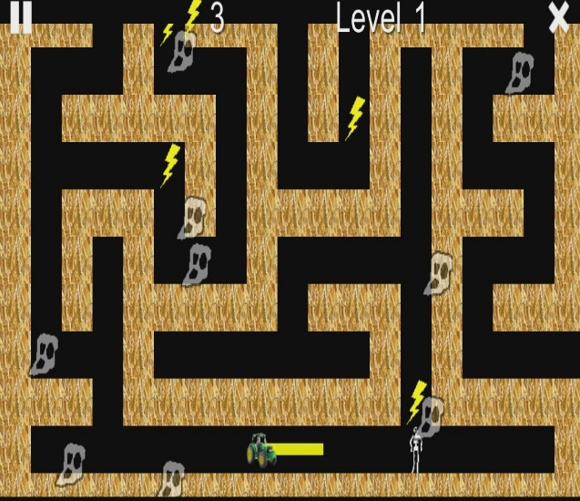

**Corn Maze Level 1 Corn Maze Logo**

1. – Inspiration

When deciding on what game we wanted to create, we all knew that it needed to be something that would keep people interested, something to get your heart racing and make you want to play again when you lose. Given that large number of competitors in this field currently, we are aware that we will have to create something somewhat unique. While we don’t want our game to be a replica, we will be taking some inspiration from other games.

While we won’t have in-app purchases right away it may be something we  
might consider in the future. We do plan on having multiple ‘levels’ (mazes)  
with a different approach to level design implemented in each maze.

1. **- Project Plan**

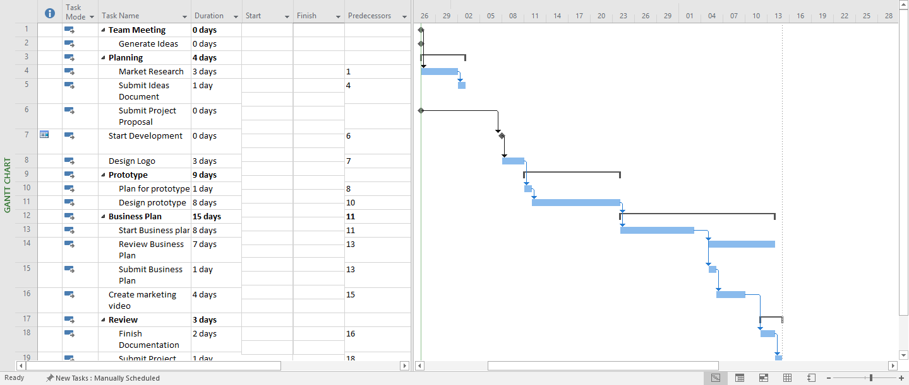

**Project Plan Created in Microsoft Project**

The Project plan allows us to lay out clearly defined tasks and deadlines  
for the project. These deadlines ensure that everyone knows what work needs  
to be done for the project and when it needs to be completed by. This type  
of planning also makes sure that the project doesn’t halt to a stand-still.  
By assigning milestones to some of the more important tasks, we can view  
and track how the project is progressing. These landmark tasks are easy to spot  
on the Gantt chart as they are represented by a dark diamond symbol.  
This approach to the project will also help to keep us focused on the present  
tasks and not jump too far ahead in the projects’ development cycle. This  
should also help to motivate us to keep working hard on the project  
throughout the year as any break in the projects’ development cycle will  
lead to project slack and this will affect the estimated finishing time of the  
project. As students we have an obligation to have the project submitted prior  
to the deadline so this milestone cannot move for our project. As we are  
only in the early stages of the project many of the other tasks in the project  
plan above are subject to change.

1. **- SWOT Analysis**

The SWOT analysis allows us to look at the project from different viewpoints   
and analyse what the projects strengths, weaknesses, opportunities and   
threats are. This will give us a better understanding of how we can build  
 on the strengths of our project and mitigate any potential weaknesses or threats.

|  |  |  |  |
| --- | --- | --- | --- |
| **Strengths** | **Weaknesses** | **Opportunities** | **Threats** |
| Powerful game engine (Unity). | First person game may not be appropriate for mobile gaming. | Fast growing market. | Increasing competition. |
| The games concept should be easy to implement. | Limited time and resources to produce the game. | Lots of community help for unity online. | Similar games already available. |
| Score system increases replay value of the game. | We are all beginners in game development | The games design may allow for virtual reality compatibility | Difficult to market and promote small game |
| Time limit helps to immerse the player in the game. |  | If the game was successful we could explore other markets (Apple store) |  |

When we were analysing our SWOT we were delighted to see that we have  
more strengths and opportunities than weaknesses and threats. This  
is a clear indication that not only is our project feasible, but it has the   
potential to be very successful. We will try and work towards our strengths in   
this project. We want to utilise all the community help that’s available for   
unity online. There are some excellent unity tutorials on YouTube which   
could prove invaluable when we’re trying to hone our unity skills later in the   
project. There’s also a unity documentation website which could offer  
 us help us with the coding aspect of the game.

We felt that game immersion was also a major strength for our project.   
The hectic nature of our game should make the player feel deeply involved   
in the gameplay. The combination of a time limit and scoring system  
that puts the players score on a leaderboard adds a competitive aspect   
to the game.

The main source of threats to our project comes from the ever-increasing   
competition in the gaming market and the concrete deadline that has been   
placed on the project. We need to try our best to work around and if   
possible, eliminate these threats. We will be aiming to avoid any direct   
competition by identifying a target market which we feel we can realistically   
reach with our game. We will also need to consider if we want to include   
advertising in the game. This decision may come down to how we plan   
to compete with our competitors. There is nothing that we can do about  
the time restriction on the project. The best we can do is alleviate the   
severity and likelihood of the threat by following our project plan and try not  
to delay or push back any tasks.

**7.0 - Website**

The website for our project will be designed to encourage the visitor   
to download our game. The website will feature the promotional   
video, screenshots and concept art for the game. There will be an about   
page where the visitor can find out more information about the game and   
a contact us page where they can get in contact with us if they have any   
questions. Having visited many similar websites for mobile games we   
discovered that they placed an emphasis on high quality graphics and used   
minimal text when designing their sites. We may decide to adopt a similar   
approach when we develop our website. We realised that the website would   
not be the centerpiece of our project but rather a means of getting our   
game to the consumer. By giving the website an eye-catching design and   
making it simple to navigate we would be increasing the chances that the   
user will download our game.

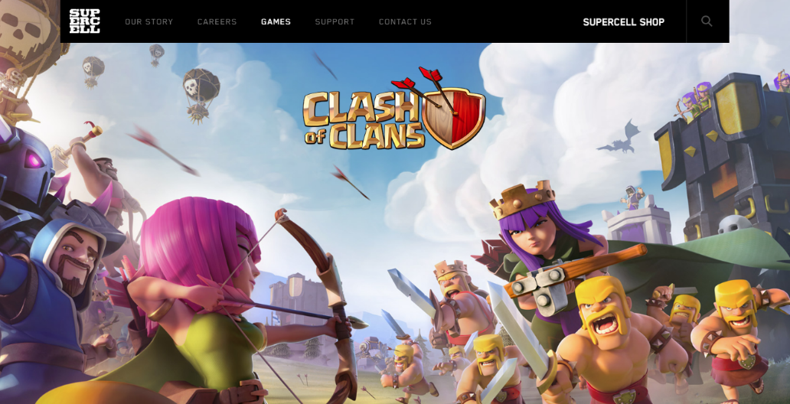

**Clash of Clans Website**

**8.0 - Website Flow Chart**

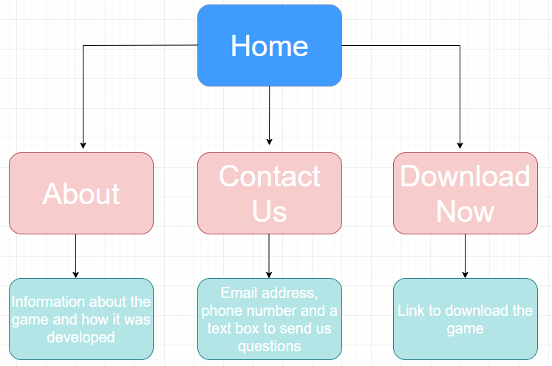

**Flow Chart for website – Subject to change**

This flowchart will give us a better understanding of how we are going to design  
website when we reach that stage in the project. We decided to keep the number   
of pages in the website to a minimum. This will ensure that the visitor is not   
daunted by the site. The home page will feature very little text.   
  
It will have a high-quality picture of our game in the background. We will have   
a big download now button on the page. We want this to be the first thing that   
the user sees when they visit the site. There will also be a navbar running   
along the top with options to go to the about page, the contact us page and the   
download now page.

The about page will have lots of information about the game, screenshots, a   
promotional video concept art, and how the game was developed.   
The contact us page will have our email address, phone number and a text box   
that will allow the user to send us a message if they have any queries about the game.

We’ve learned that customers are usually very cautious about downloading   
software from unknown sources so by including a contact page with our details   
it makes us seem more genuine and creates an element of trust between us   
and our customers. The download now page will allow the user to select what   
version of the game they wish to download. It is yet to be decided which platforms   
our game will be available on, but windows and android seems the most   
likely platforms. We want to make it as easy as possible for the user to download   
the game. The simple design will streamline the downloading process and   
should lead to a larger number of people opting to download the game.

**9.0 - Game Flow Chart**

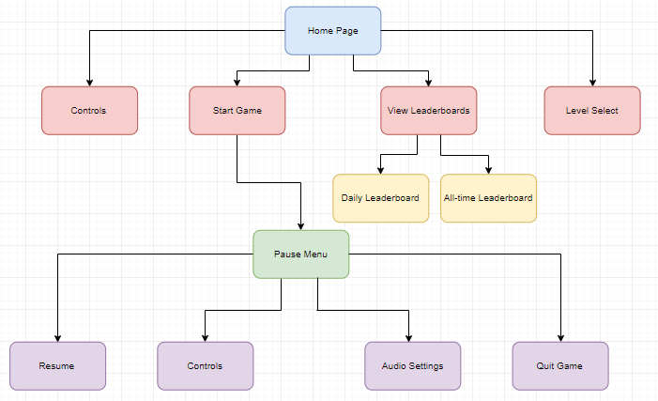

**Flow Chart for Game – Subject to change**

By making a flow chart for the game, we’re able to imagine how our game is going   
to be structured. The flow chart will act as a blueprint for the games’ menu system.   
It’s a good idea to start thinking about the layout of the game and how it will look at   
an early stage of the project. This can act as a mini feasibility study for the game.   
We would like to try and keep the menu for the game simple and easy to use.   
Many games suffer from having large complicated menu systems which allows   
the player to adjust every setting imaginable. While being able to tailor any   
setting in the game to your personal specification might sound like a desirable   
feature to have, it’s likely that having a menu with that level of depth might make   
novice gamers apprehensive and confused. For this reason, we want to keep the   
menu as simple and easy to navigate as possible. We may have different ideas on   
how the game should be laid out as our project progresses. Some aspects may   
be added or removed so the flowchart above is subject to change.

1. **- Logo Design**

When designing a logo for the game we felt that it was important to try   
and create something that was simple but memorable. In recent years   
many large organisations have been re-branded and created new logos.   
A re-occurring trend in these logos is that they have become a lot less cluttered   
and have a simpler design. The resulting logos that have emerged are   
ultimately tidier and more memorable than their predecessors. We want to   
follow this approach to design and try and make our logo leave a lasting impact   
on our customers. With this in mind, we began sketching some possible   
ideas for a logo. We were excited at the prospect of incorporating the maze   
aspect of the game into the logos design. While this was a challenge, it was   
one which encouraged us to be creative.

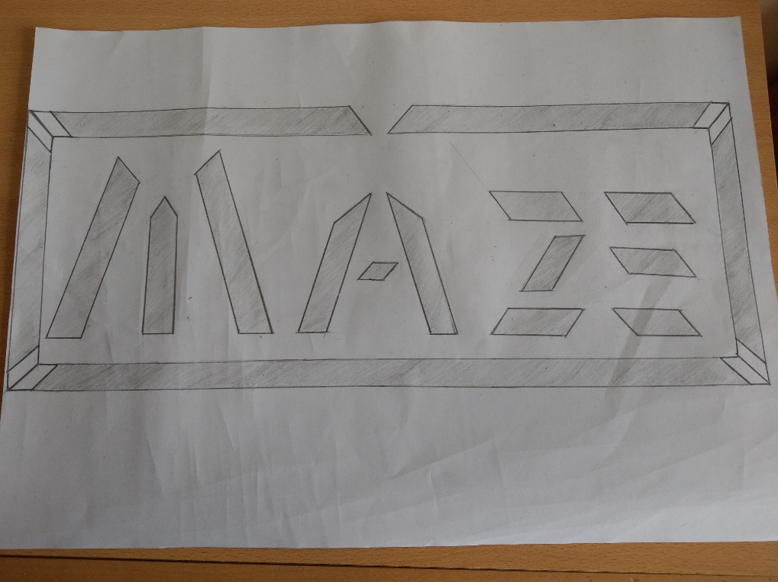

**Possible Logo Idea – Subject to change**

We still have not agreed on a logo for the project, but we have come up with   
some interesting ideas that we will be sure to revisit later in the project. One of the   
ideas can be seen in the image above. These type of rough sketches helps to give   
us a better idea of how the logo will look after it’s been created digitally in Adobe   
Illustrator and Adobe Photoshop. The broken letter design and hard angles   
create an unusual aesthetic which is reminiscent of a maze. The gaps in the letters   
are space for the player to move through as if they are trying to find their way out   
of the maze. The break at the top of the surrounding border is to act as an exit   
point to the maze. The digital version will be much more colourful and vibrant   
than this but for planning purposes we feel it’s important that we make sure   
that the logo looks correct on paper before we start using adobe illustrator.   
This was just one of many design ideas that we had for the logo. As the project   
progresses we may feel that we can create a better logo, for that reason the logo   
above is subject to change.

**11.0 - High Score System / Database**

We have envisioned having a score system for our game. This system needs to meet three conditions, it needs to be accessible from anywhere so if our users go abroad they can access their scores. It needs to store a user ID for when the user logs in their previous score which is already there will entice them to try and beat it. Our system needs to be efficient so that it can handle multiple users at once and doesn’t slow down. Finally, it needs to be able to rank score from highest to lowest.

Three reasons a traditional database may not be sufficient for our needs particularly due to the need to rank score in addition to having multiple leaderboards. Through research one of the tip contenders for the solution is a technology called Redis, it is an open source, in memory data store, which can be used as a database, cache, or an archive (leaderboard)

Having a database alone is not enough, we need some way to access this database, additionally some form public API will be needed. Due to the need to service multiple end users at once we need to ensure the API is either multiple threaded or has some form of multi-tendencies. The API will need documentation so that we can encourage our users to use it. A min of two leaderboards will be needed, an overall tracking highest scores of all time and a daily leaderboard tracking score for the given day.

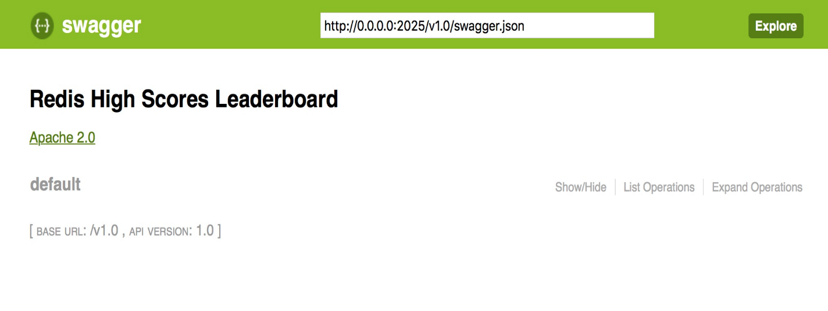

3 end point / operations that we want for our game leaderboard.

* to log user score
* to gather the leaderboard of today
* to gather highest score of the day
* leaderboard for all time.

Due to the abundance of cloud providers these days, ideally our leaderboard service should be platform agnostic, some form of virtualization or containerized solution would be ideal.

Finally, we wanted to try using some sort of embed systems because thus far we have not used an embed system throughout our course and we find that interesting.

1. **- Software**

**Unity (2018.1.0)**  
The reason we downloaded this version of Unity is the college have it installed across all computer labs. We will use Unity along with Blender to create our game world using the standard assets Unity provides along with our own imports from Blender and anything we download from the Unity store. Unity is an open source game engine meaning it has a much larger number of users. More users will result in more online forums for us to engage with. This will help greatly with the development of the project.

**Blender**  
We will use Blender to create static and dynamic 3D objects. These objects will be exported to Unity where we will add C# scripts to the objects to provide the player with some interactivity within the game world. An example of this may be collecting an item that allows the player to run faster for a period of time.

**Microsoft Visual Studio 2017 (Community)**  
We will use Visual Studio to write our C# scripts which we will then export back into Unity and attach them to objects within the game world. An example of this may be an enemy attacking the player if the player is within a certain range of the enemy.

**Adobe Photoshop**  
Photoshop will be used for us to develop our logo and promotional material. We will also be using photoshop to develop textures to attach to our objects. For example, a lush dense green and brown thick texture with some depth for some foliage within the game, perhaps a bush or garden.

**Adobe Illustrator**  
Once we have a good mock up made in Photoshop of our logo we will bring that into Illustrator and recreate it. The reason behind creating it in Illustrator as opposed to Photoshop is Illustrator uses vector graphics which results in no pixilation no matter how big or small we decide to export the logo.

**Adobe Audition**  
Upon discussing a soundtrack and how we would get some free music to add into the game we tossed around the idea of creating the music ourselves. If we decide to go down this route later in development, we can record a track on guitar or piano and bring it into Audition to splice it into sections we want for particular parts of the game. We can also manipulate the sound to be crisper and add effects to make the music more layered and arcade like.

**Adobe Premiere Pro**  
Upon capturing in game footage, we will need to create a promotional trailer for our game. We can use Premiere Pro to add visual effects and transitions, layer text over video, add music and much more.

**Visual Studio (Code)**  
We will use Visual Studio Code to write our HTML5, CSS and JavaScript files for the promotional website to go alongside the game. It will also be used to build our API for our data store which will then be imported to Redis.

**Redis**  
We will use Redis to store our leaderboard information for our users. It will act as a database store, so we can relay the scores back to the game player.

**13.0 - Controls**

This game will be controlled using the keyboard and mouse. We are going to adopt the keyboard setup gamers are more familiar with. This is known as the ‘WASD’ setup and there’s a reason it’s so popular by comparison to the directional keys.

**W** Moves the character forward  
**A** Moves the character left  
**S** Moves the character backward  
**D** Moves the character right

There are going to be power-ups and power-downs within the game that will alter the players control. This may result in the player moving faster for a period of time or the keyboard controls being backward for 10 seconds e.g. **A** moving the character right and **S** moving the character left.

We feel because this is an adrenaline inducing experience the control of the character should be precise. If we mess with the controls, it adds player engagement. Finding a balance between fun and frustrating will be a challenge to balance but we’ll get play testers for feedback before the final demo.

We also have plans to release this game on the Google Play Store for android devices. There will be touch screen controls developed. We have not yet figured out the control scheme for Android but envision it will entail holding the screen to move forward, Swipe left and right to move left and right and some action button on screen to interact with objects.